**Two Types of source control**

* Centralized
* Decentralized : Git, Mercurial

1. Git

* Distributed version control
* Own File Structure
* Git is used locally with

1. GitHub

* Repository hosting service
* GitHub for local repository hosting
* Website hosting
* Github desktop

**How Git works ?**

* Create new git repository

Git init : Initialized empty git repository



Git Configuration

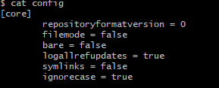

**Git Object Types**

Blob : Git stores file

Tree :

Commit :

Annotated Tag :

**Working Directory, Staging Directory and Git Repository**

Staging area = Index (working directory <-> git repository)

**List Files in the staging area**

Git ls-files

**Move Files from staging area to repo**

# Basic Git Operations

* Commit : same structure as blob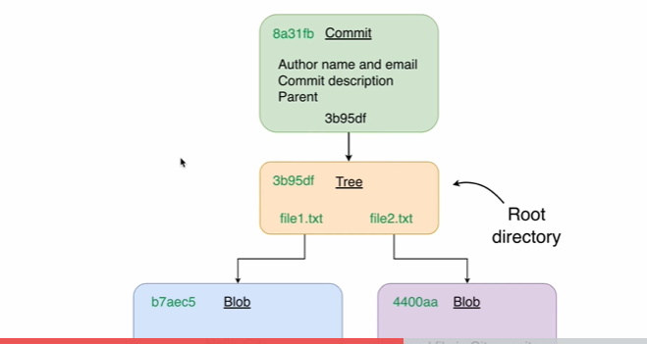

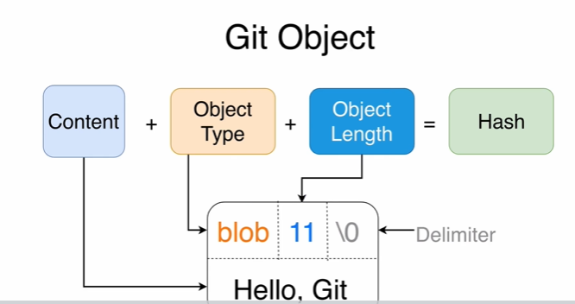

# Global configuration : Git

Author name and email

Git config –global user.name

Git config –global user.email

Git config –list

* Git status
* Git commit -m “”msg”